Name: Diyana Shrestha

**MANKATO AUTOSHOP**

1. **Entity types**

Department: Department of the auto shop

Employee: The people who work in the auto shop

Salesrep: The sales in the auto shop

Admin: The admin of the auto shop

Support: The support for the auto shop

Orders: The orders given by the customers

Payment: The payment given by the customers

Customer: The customer who buys cars from the auto shop

Retail: Customer buying cars in retail price

Wholesale: Customer buying cars in wholesale price

Ordline: Ordering products by the customer

Parts: Parts ordered by the customer

Carpart: Car parts ordered by the customer

Cars: Cars in the auto shop

1. **Relationship Types and Attributes**

Attribute of Department: (DEPT_ID, DEPT_NAME, DEPT_LOCATION)

One department can have only one department id at one time.

Attribute of Employee: (EMP_ID, EMP_NAME, EMP_ADDRESS, EMP_PHONE, EMP_SALARY, EMP_TAXID, EMP_TYPE, DEPT_ID)

Attribute of Salesrep: (EMP_ID, SR_TOTSALES, SR_COMMISSION)

Attribute of Admin: (EMP_ID, ADM_TITLE, ADM_BONUS)

Attribute of Support: (EMP_ID, SP_AREA, SP_CERTNUM, SP_CERTDATE)

Attribute of Orders: (ORD_NUM, ORD_DATE, ORD_SHIPADDRESS, CUS_ID, ORD_SUBTOT, ORD_TAXTOT, ORD_SHIPTOT, ORD_SHIPDATE, ORD_TOTAL, ORD_TOTPAID, ORD_STATUS, EMP_ID)

Attribute of Payment: (PYMT_ID, CUS_ID, PYMT_DATE, PYMT_AMOUNT, PYMT_TYPE, PYMT_REF)

Attribute of Customer: (CUS_ID, CUS_NAME, CUS_ADDRESS, CUS_PHONE, CUS_SHIP_ADDR, CUS_LASTPURDATE, CUS_LASTPYMTDATE, CUS_TYPE, CUS_EMAIL)

Attribute of Retail: (CUS_ID, CUS_CC, CUS_CC_NUM, CUS_CC_EXP_DATE)

Attribute of Wholesale: (CUS_ID, CUS_CNAME, CUS_CPHONE, CUS_CEMAIL, CUS_PONUM, CUS_PODATE, CUS_DISCOUNT, CUS_BILLADDRESS, CUS_TAX_STATUS, CUS_TAX_ID)

Attribute of Ordline: (ORD_NUM, ONLINE_NUM, PART_ID, OLINE_QTY, OLINE_PRICE)

Attribute of Parts: (PART_ID, PART_DESCRIPT, PART_PRICE, PART_QOH)

Attribute of Carpart: (CAR_ID, PART_ID)

Attribute of Cars: (CAR_ID, CAR_MANUF, CAR_MODEL, CAR_YEAR)

1. **Entity type**

Department

Primary Key: DEPT_ID

Employee

Primary Key: EMP_ID

Foreign Key: DEPT_ID

Salesrep

Primary Key: EMP_ID

Foreign Key: EMP_ID

Admin

Primary Key: EMP_ID

Foreign Key: EMP_ID

Support

Primary Key: EMP_ID

Foreign Key: EMP_ID

Orders

Primary Key: ORD_NUM

Foreign Key 1: EMP_ID

Foreign Key 2: CUS_ID

Payment

Primary Key: PYMT_ID

Foreign Key: CUS_ID

Customer

Primary Key: CUS_ID

Retail

Primary Key: CUS_ID

Foreign Key: CUS_ID

Wholesale

Primary Key: CUS_ID

Foreign Key: CUS_ID

Ordline

Primary Key: ORD_NUM, ONLINE_NUM

Foreign Key 1: ORD_NUM

Foreign Key 2: PART_ID

Parts

Primary Key: PART_ID

Carpart

Primary Key: CAR_ID, PART_ID

Foreign Key 1: CAR_ID

Foreign Key 2: PART_ID

Cars

Primary Key: CAR_ID

1. **ERD DIAGRAM**

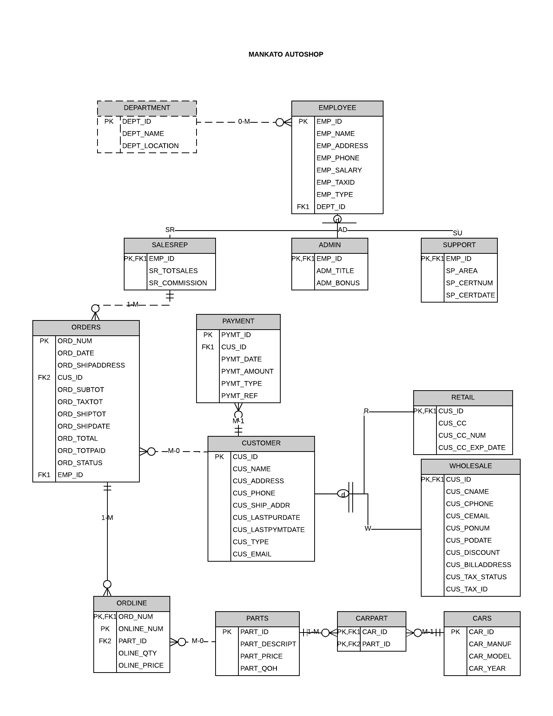

1. CREATE TABLE `department`(

`dept_id` INT NOT NULL,

`dept_name` VARCHAR(255) NOT NULL,

`dept_location` VARCHAR(255) NULL,

PRIMARY KEY(`dept_id`)

);

CREATE TABLE `employee`(

`emp_id` INT NOT NULL,

`emp_name` VARCHAR(255) NOT NULL,

`emp_address` VARCHAR(255) NOT NULL,

`emp_phone` VARCHAR(30) NOT NULL,

`emp_salary` INT NOT NULL,

`emp_taxid` INT NOT NULL,

`emp_type` VARCHAR(255) NOT NULL,

`dept_id` INT NOT NULL,

PRIMARY KEY(`emp_id`),

FOREIGN KEY(`dept_id`) REFERENCES `department`(`dept_id`)

);

CREATE TABLE `salesrep`(

`emp_id` INT NOT NULL,

`sr_totalsales` FLOAT DEFAULT 0.0,

`sr_commission` FLOAT DEFAULT 0.0,

PRIMARY KEY(`emp_id`),

FOREIGN KEY(`emp_id`) REFERENCES `employee`(`emp_id`)

);

CREATE TABLE `admin`(

`emp_id` INT NOT NULL,

`adm_title` VARCHAR(255) NOT NULL,

`adm_bonus` FLOAT DEFAULT 0.0,

PRIMARY KEY(`emp_id`),

FOREIGN KEY(`emp_id`) REFERENCES `employee`(`emp_id`)

);

CREATE TABLE `support`(

`emp_id` INT NOT NULL,

`sp_area` VARCHAR(255) NOT NULL,

`sp_certnum` INT,

`sp_certdate` DATE,

PRIMARY KEY(`emp_id`),

FOREIGN KEY(`emp_id`) REFERENCES `employee`(`emp_id`)

);

CREATE TABLE `customer`(

`cus_id` INT NOT NULL,

`cus_name` VARCHAR(255) NOT NULL,

`cus_address` VARCHAR(255) NOT NULL,

`cus_phone` VARCHAR(255) NOT NULL,

`cus_ship_addr` VARCHAR(255) NOT NULL,

`cus_lastpurdate` DATE,

`cus_lastpymtdate` DATE,

`cus_type` VARCHAR(5) NOT NULL,

`cus_email` VARCHAR(255) NOT NULL,

PRIMARY KEY(`cus_id`)

);

CREATE TABLE `retail`(

`cus_id` INT NOT NULL,

`cus_cc` VARCHAR(255) NOT NULL,

`cus_cc_num` INT,

`cus_cc_exp_date` DATE,

PRIMARY KEY(`cus_id`),

FOREIGN KEY(`cus_id`) REFERENCES `customer`(`cus_id`)

);

CREATE TABLE `wholesale`(

`cus_id` INT NOT NULL,

`cus_cname` VARCHAR(255) NOT NULL,

`cus_cphone` VARCHAR(255) NOT NULL,

`cus_caddress` VARCHAR(255) NOT NULL,

`cus_ponum` INTEGER NOT NULL,

`cus_podate` DATE NOT NULL,

`cus_discount` FLOAT,

`cus_billaddress` VARCHAR(255),

`cus_tax_status` VARCHAR(255) NOT NULL,

`cus_tax_id` VARCHAR(255) NOT NULL,

PRIMARY KEY(`cus_id`),

FOREIGN KEY(`cus_id`) REFERENCES `customer`(`cus_id`)

);

CREATE TABLE `payment`(

`pymt_id` INT NOT NULL,

`cus_id` INT NOT NULL,

`pymt_date` DATE NOT NULL,

`pymt_amount` FLOAT,

`pymt_type` VARCHAR(255) NOT NULL,

`pymt_ref` INT,

PRIMARY KEY(`pymt_id`),

FOREIGN KEY(`cus_id`) REFERENCES `customer`(`cus_id`)

);

CREATE TABLE `orders`(

`ord_num` INT NOT NULL,

`ord_date` DATE NOT NULL,

`ord_shipaddress` VARCHAR(255) NOT NULL,

`cus_id` INT NOT NULL,

`ord_subtot` FLOAT NOT NULL,

`ord_taxtot` FLOAT NOT NULL,

`ord_shiptot` FLOAT NOT NULL DEFAULT 0,

`ord_shipdate` DATE NOT NULL,

`ord_total` FLOAT NOT NULL DEFAULT 0,

`ord_totpaid` FLOAT NOT NULL DEFAULT 0,

`ord_status` VARCHAR(255) NOT NULL,

`emp_id` INT NOT NULL,

PRIMARY KEY(`ord_num`),

FOREIGN KEY(`emp_id`) REFERENCES `salesrep`(`emp_id`),

FOREIGN KEY(`cus_id`) REFERENCES `customer`(`cus_id`)

);

CREATE TABLE `parts`(

`part_id` INT NOT NULL,

`part_descript` INT NOT NULL,

`part_price` FLOAT NOT NULL,

`part_qoh` INT NOT NULL,

PRIMARY KEY(`part_id`)

);

CREATE TABLE `cars`(

`car_id` INT NOT NULL,

`car_manuf` VARCHAR(255) NOT NULL,

`car_model` VARCHAR(255) NOT NULL,

`car_year` INT NOT NULL,

PRIMARY KEY(`car_id`)

);

CREATE TABLE `carpart`(

`part_id` INT NOT NULL,

`car_id` INT NOT NULL,

PRIMARY KEY(`part_id`, `car_id`),

FOREIGN KEY(`part_id`) REFERENCES `parts`(`part_id`),

FOREIGN KEY(`car_id`) REFERENCES `cars`(`car_id`)

);

CREATE TABLE `ordline`(

`order_num` INT NOT NULL,

`online_num` INT NOT NULL,

`part_id` INT NOT NULL,

`online_qty` INT NOT NULL,

`online_price` FLOAT NOT NULL,

PRIMARY KEY(`online_num`, `order_num`),

FOREIGN KEY(`order_num`) REFERENCES `orders`(`ord_num`),

FOREIGN KEY(`part_id`) REFERENCES `parts`(`part_id`)

);